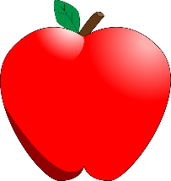

Apple Supply List
- 1 Package of White Card Stock
- 1 Package of Colored Card Stock
- 1 Pack of 6 Purple Glue Sticks
- 1 Pack of Crayola Crayons
- 1 Pack of Crayola Markers
- 1 Pack of Q-Tips
- 1 Pack of Band-Aids
- 1 Jar of Washable Red Paint (about 32oz)
- 1 Jar of Washable Pink Paint (about 32oz)
- 1 Box of Tissues
- 1 FULL Size Backpack (labeled)
- 1 Outfit in a baggie (labeled and left in backpack)
- 1 Water Bottle (labeled and left in backpack)
**No supplies need to be labeled besides the change of clothes, water bottle and backpack

