Meet the Teachers at SonShine Preschool
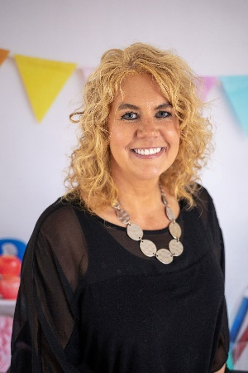
Cory Burough,Director, Lead Teacher
Hi, I'm "Miss Cory," or "Miss Cowey," for most of the kids who can’t say their R's yet. I have been teaching at SonShine Preschool since 2013, and I really have a good time going to work every day. I became the director the summer of 2021 and I am also taking classes at Aims.
I grew up in North Dakota, and have lived in Greeley for 25 years. Greeley First has been my home church for that time as well, and is also where I got married 22 years ago. I enjoy singing on the worship team. I also assist my husband, Mark, with his lawn care and snow removal business of 25 years, mostly in the office.
My background starts with 18 years of retail management, beginning with Christopher and Banks, supervising 13 stores with lots of travel and exciting challenges. I then managed Victoria's Secret. After I had my 2nd daughter, I decided to stay home and do home child care, which I enjoyed for 8 years before starting at SonShine Preschool.
My two daughters keep me on the go! My oldest is an esthetician, and my youngest is attending cosmetology . I also love to go on bike rides and do yoga.
I love working with preschoolers because they say whatever is on their mind and have great senses of humor. I love to have fun with them! Making up rhyming songs for the kids is a favorite of mine. Thank you for letting me have fun and learn with your kids. I love to see them learn things that will continue on with them forever!

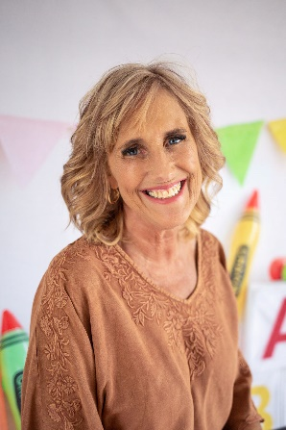
Kim Deines, Lead Teacher
Dear Preschool Families,
My name is Kim Deines, and I am so happy and excited to be a member of the SonShine Preschool staff and family since late 2018.
I have lived here in Greeley since 1992 and raised my 3 amazing sons here. Jackson is 27, Parker is 25, and Grant is 22. I am excited to be a new Nana, and love caring for my grandchildren on my days off. I was born in NY and moved to Fort Collins in 1975. I graduated from Fort Collins High School in 1983, then attended Fort Lewis College where I graduated with a BA in Sociology and Social Work in 1988. I am in the process of taking some Early Childhood Education classes at Aims Community College. I began my teaching career at Jack and Jill Preschool as a lead teacher, and then became an Assistant Director at A Children's Workshop in Fort Collins.
Similar to our other teachers, I started my own licensed in-home daycare after the birth of my first son. Over the next five years, my daycare evolved into my own preschool, "Kim's Adventures in Learning," which I owned and taught at for the next 12 years. I stopped running my own preschool a few years ago and took some extra time with my children, traveling and starting a small furniture refinishing business, but I missed those preschoolers and am thrilled to be back teaching again.
My passion is teaching young children and being able have the privilege of helping to prepare them academically, emotionally, and socially for kindergarten. I have always had wonderful relationships with my preschoolers and their families, and I have been fortunate to see them grow up, attend their high school and college graduations, and even meet some of their young children.

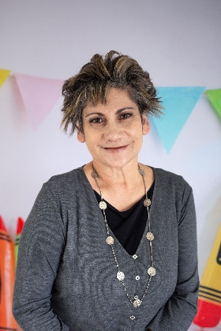
Debbie Gonzales, Assistant Teacher
Hello, I am Debbie. I started here at SonShine Preschool August, 2021. I am loving it here. It’s an Amazing group of Fun ladies—We sure love and adore our students. They make our day extra Special. Thank You for sharing them with us—Such a JOY!!
I had the privilege of working for District 6 (McAulliffe) for 11 years. I loved my years there. I left there to help with my Grandson and now I am able to have him in my class here.

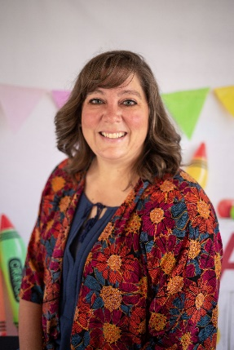

Faith Voegeli, Assistant Teacher
Hello, my name is Faith and I have been teaching the children at SonShine Preschool since 2016. I have been married since 2003 and have been blessed with two children. As a mother, I am very aware of the trust and decision making it takes to select the perfect place for your child.
I have a background in caring for and providing instruction to pre-k children as a self-employed daycare provider. I am passionate about the growth and development of young children and had the opportunity to assist intermittently during the 2014 and 2015 preschool years at SonShine preschool. The time spent with the children and staff was such a positive experience, and now I am pleased to be a part of the incredible team at SonShine. I am committed to demonstrating compassion and professionalism in caring for the students because I know and believe that how children are taught and cared for will last a lifetime.
"Start children off on the Way they should go, and even when they are old, they will not turn from it." Proverbs 22:6

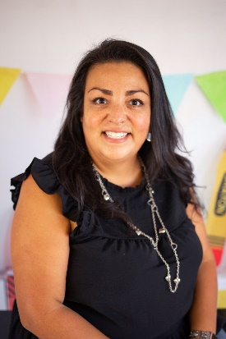
Jaime Guerrero, Lead Teacher
Hello, Parents!
My name is Jaime Guerrero, and I am thrilled to be working with your children! To tell you a little about myself, I achieved my Degree in Early Childhood in the summer of 2002 and was employed with Head Start for 11 years. I have also volunteered at several Greeley schools and cared for children at my home childcare.
In 2010, we welcomed our second child, and my husband and I decided it would be best for me to stay at home with our children for a while. God brought us to SonShine Preschool in August of 2013 when our son began attending preschool here. We loved it so much, he attended a second year in 2014 and I was a regular volunteer for both years. I am pleased and excited to be a part of the SonShine Preschool Staff since 2015. In the summer 2018, we welcomed our third baby girl Novalyn. Novalyn now attends Sonshine Preschool and loves it!

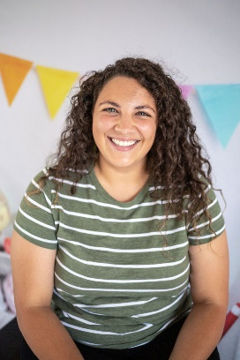
Lexi Millsap, Floater, Administrative Assistant
Hi, I am Lexi and I started at SonShine Preschool in 2021. My son attends SonShine and he loves it! He was born in 2017 and he is all boy. We love anything Disney and we call it our second home.
I started working at a wrap around preschool in 2016 as a Special Education Para. I loved working one on one with a student. I moved to an elementary school to be one of two special education paras within the elementary school. I also worked for a summer program for students who were in K-5. We would do fun activities and learning stations throughout the day. I have loved working with all age groups, but the younger kids keep me on my toes and make the day so fun. They are so full of energy and honesty! I look forward to getting to work at SonShine and getting to know your students.
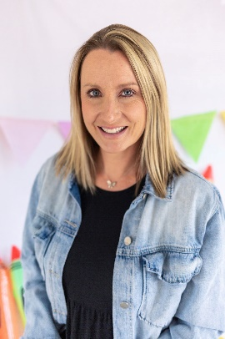

Kelly Jennings, Assistant Teacher
Hello! My name is Kelly Jennings. I’ve been with SonShine since 2021, and I’m loving every minute of it! Besides being here, I have been a volunteer at Scroll and Fan, a local non-profit that helps clothe the kids of district 6. I am passionate about this community of ours, and have lived in Greeley since 2002.
I have two kids, that keep me super busy. One is a sixth grader and one is a junior in high school. They play ALL the sports! I’ve spent years volunteering in their classrooms and organizing their holiday parties. I love being a part of this wonderful school, meeting all the amazing kids and look forward to many more years to come.
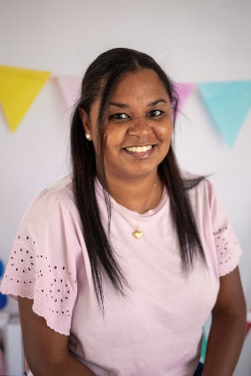
Ana Brooks, Assistant Teacher
Hi my name is Ana Brooks, and I have been a preschool assistant teacher for 2 years. I started at ABC Child Development Center in 2017-2018. After ABC, I took a break to take care of my little girl who is 3 years old and she also goes to SonShine Preschool. She loves it at SonShine, and she enjoys being with her friends and learning about Jesus. We love to travel, and find new fun parks. The beach is one of our favorite places. I have been with SonShine Preschool since February 2022, and I have enjoyed teaching, learning, and working with great teachers. The students always make them grow and learn knew things

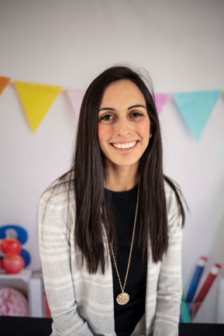
Renee Cavazos, Lead Teacher
Hi sweet friends, my name is Renee Cavazos. I am new to SonShine Preschool, but not new to teaching. I graduated from the University of Northern Colorado with a degree in Elementary Education with an emphasis in ESL. I taught Second grade and Kindergarten for 11 years at Frontier Academy. I loved teaching there and have always had a passion for teaching ever since I was a child myself.
I have been married for 5 years and a Mommy for 3 years. After the birth of our son, Frontier was able to offer me a part-time position, of which I am extremely grateful. After my daughter was born last year, I realized the part time path seemed to be exactly what was best for me and my family.
My son is now ready for preschool and I was hopeful to find a job where he could join me in his school journey. We are truly blessed because God led us here! We both already love SonShine Preschool! I can’t wait to start building memories with your children and help them to learn and grow as preschoolers.
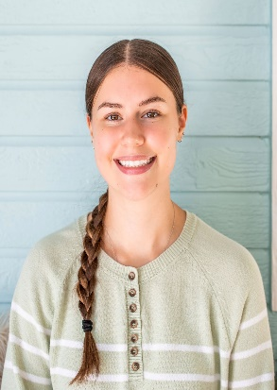
Paige Kelly, Lead Teacher
Bio Coming Soon!

