

**Frog Supply List**

* 1 Package of White Computer Paper
* 1 Package of Colored Card Stock
* 1 Pack of 6 Purple Glue Sticks
* 1 Pack of Crayola Crayons
* 1 Pack of Crayola Markers
* 1 Set of Watercolors
* 1 Box of Tissues
* 1 Pack of Swifter Pads

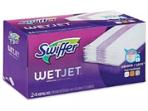

* 1 Jar of Washable Orange Paint (about 32 oz)
* 1 Jar of Washable Red Paint (about 32 oz)
* 1 FULL Size Backpack (labeled)
* 1 Outfit in a Baggie (labeled and left in backpack)
* 1 Reuseable Water Bottle (labeled and left in backpack)

** No supplies need to be labeled besides the change of clothes, water bottle, and backpack