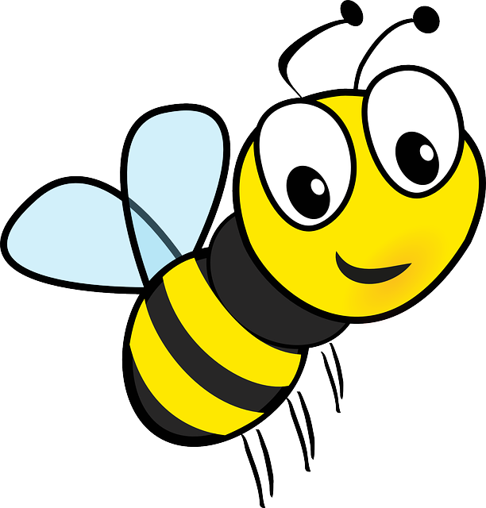
Bee Supply List
- 1 Package of White Computer Paper
- 1 Package of Black Construction Paper
- 1 Pack of Colored Pencils
- 1 Pack of 4 Purple Glue Sticks
- 1 Pack of Crayons
- 1 Pack of Markers
- 1 Pack of Staples
- 1 Pack of Scotch Tape Refills
- 1 Pack of Baby Wipes
- 1 Container of Clorox Wipes
- 1 Can of Lysol Spray
- 1 Box of Tissues
- 1 Jar of Washable Pink Paint
- 1 Bag of Rice
- 1 FULL Size Backpack (labeled)
- 1 Outfit in a baggie (labeled and left in backpack)
** No supplies need to be labeled besides the change of clothes and backpack

